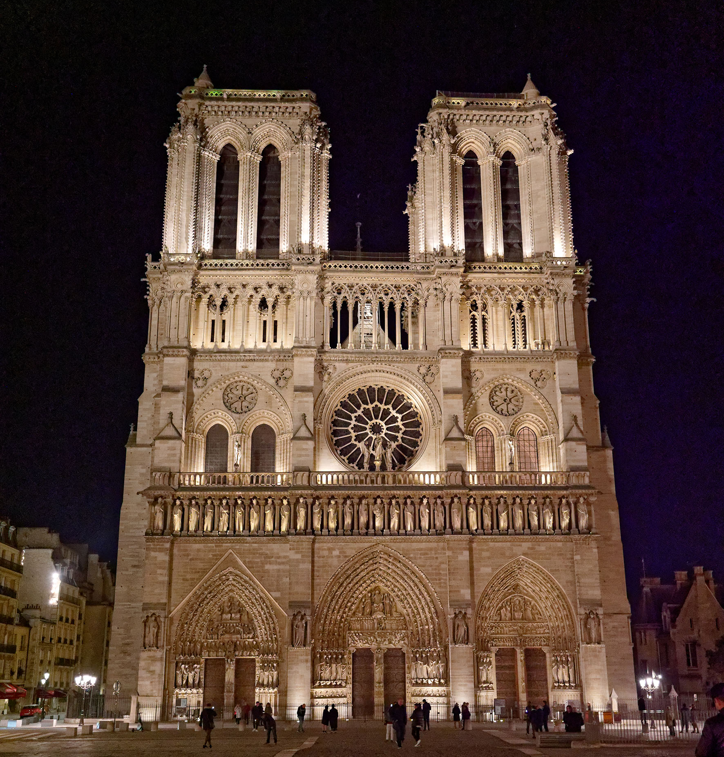
Notre-Dame de Paris (Photo credit: Yannick Boschat)

Sennheiser supports the resurrection of Notre-Dame de Paris with Spectera

Paris, France, January 2026 – After the terrible fire, it took only five years of – albeit extremely intensive – work to rebuild the Notre-Dame de Paris cathedral. Novelty, the integrator responsible for re-equipping Notre-Dame, was consulted two years prior to the cathedral’s reopening to supply a new sound system, with the specifications calling for expanded coverage while keeping all technical equipment as discreet as possible. After an in-depth study, it became clear that only Sennheiser’s Spectera wideband wireless system ticked all the boxes of the stringent specifications.

Large RF coverage and high reliability
When David Créteur, project lead at Novelty, started to look into the RF wireless equipment for the cathedral, he quickly realised they needed a new solution that would satisfy the demands that came with the reconstruction of Notre-Dame de Paris. The new specifications included sound reinforcement for mobile celebrations, where the priests or the archbishop would move about whilst still being heard clearly without any dropouts. In addition, the use of new spaces such as the side chapels had to be factored in. In a nutshell: RF coverage had to be ensured throughout the entire length of the cathedral, from the entrance of Notre-Dame to the chapel of the Crown of Thorns reliquary located at the very back, and across its width, where obstacles like wooden partitions and massive stone pillars had to be overcome.

Inside view of Notre-Dame de Paris cathedral, giving an idea of the area that is covered with just four antennas  (Photo credit: Julio Piatti, Notre-Dame) | 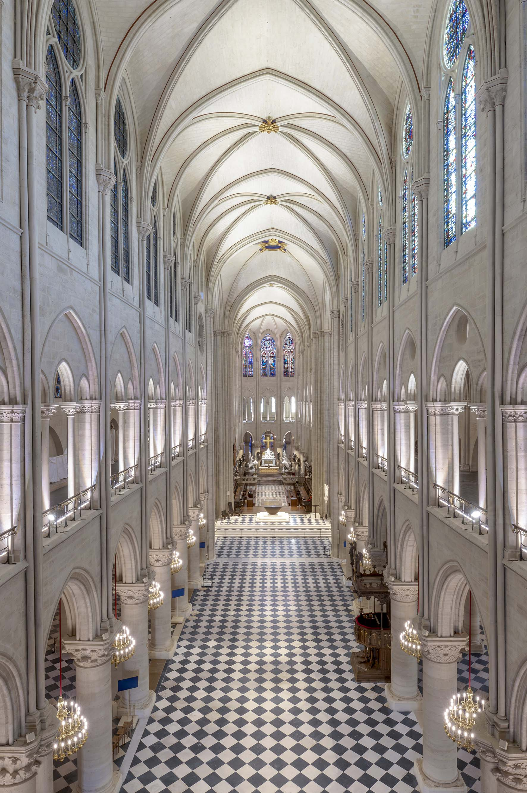

A place of sharing open seven days a week
Beyond ensuring reliable RF coverage across almost the entire cathedral, Créteur was looking for a system that was discreet and easy to operate, knowing that Notre-Dame has to combine spiritual life with welcoming the public. As a place of worship, Notre-Dame de Paris has always been freely accessible to all. “Notre-Dame is a place of sharing open to all visitors, whether they wish to attend a service or just want to walk under its vaults,” says Laurent Prades, technical manager of Notre-Dame de Paris. “This is what makes this cathedral so unique: It welcomes the whole world, worshippers and visitors alike, with services being held during visits, and visits continuing during services.”

In practice, Notre-Dame remains a place of prayer and contemplation for the thousands of worshippers who can attend five services every day of the week. But it is also a place open to the public 12 hours a day, seven days a week, 365 days a year.

One of the special features of Notre-Dame is the fact that the cathedral is open to the public the entire week. While mass is celebrated at the centre, a consistent stream of visitors circles around the priests  (Photo credit: Jean-Baptiste Delerue) | 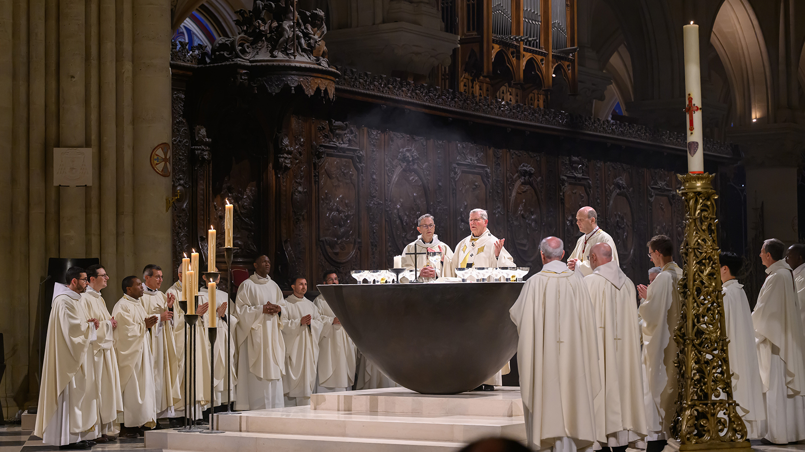

In search of the right wireless audio technology
In view of the new requirements and the exceptional operating conditions, the question was which wireless system to use? Notre-Dame’s old system relied on an analogue two-channel Sennheiser 3000 series receiver and a pair of active directional antennas placed at the centre of the liturgical podium. This heritage system was testament to the effectiveness and long-term reliability of Sennheiser wireless, but given the area to be covered, Créteur felt it was time to move on from analogue: “Instead of working only along the axis, we now had to cover almost the entire cathedral, which is just over a hundred metres long from the entrance to the back and almost 50 metres wide at the transept.

“With the digital wireless technologies we were familiar with, we could have done it, but we would have had to multiply the number of antennas to a total of at least eight to be placed throughout the building, and then connect them with long lengths of cable. To compensate for the rigidity and line losses associated with copper coaxial cable, we would have had to use costly fibre extension solutions, which would potentially have led to problems with combining antenna pairs and zoning. Ultimately, the installation would have been quite complex, requiring the use of numerous devices, with the added difficulty of having to activate and deactivate zones manually.”

Knowing that the installation had to run autonomously, without the constant intervention of a technical manager, Créteur had to find another solution.

Spectera solves all problems
Turning away from traditional RF wireless technologies, which were decidedly too complex to implement, Créteur briefly considered switching to a DECT-based solution. Then, during a chance encounter with a Sennheiser presentation, he discovered the possibilities offered by Sennheiser’s WMAS implementation, the new Spectera system: “The further we got into the presentation, the more Spectera seemed to solve the problems one by one, and to perfectly meet the specific requirements of our project by considerably simplifying the system and its installation. First of all, unlike traditional wireless systems, Spectera does not need diversity, so with comparable or even superior coverage, we can go from eight antennas to four, which halves the cabling. Secondly, the antennas combine perfectly without the need for a technician to intervene, eliminating the operational difficulties associated with zoning. And finally, the antennas are connected via Ethernet cables, a standard that is easier to integrate and more affordable than coaxial cable.”

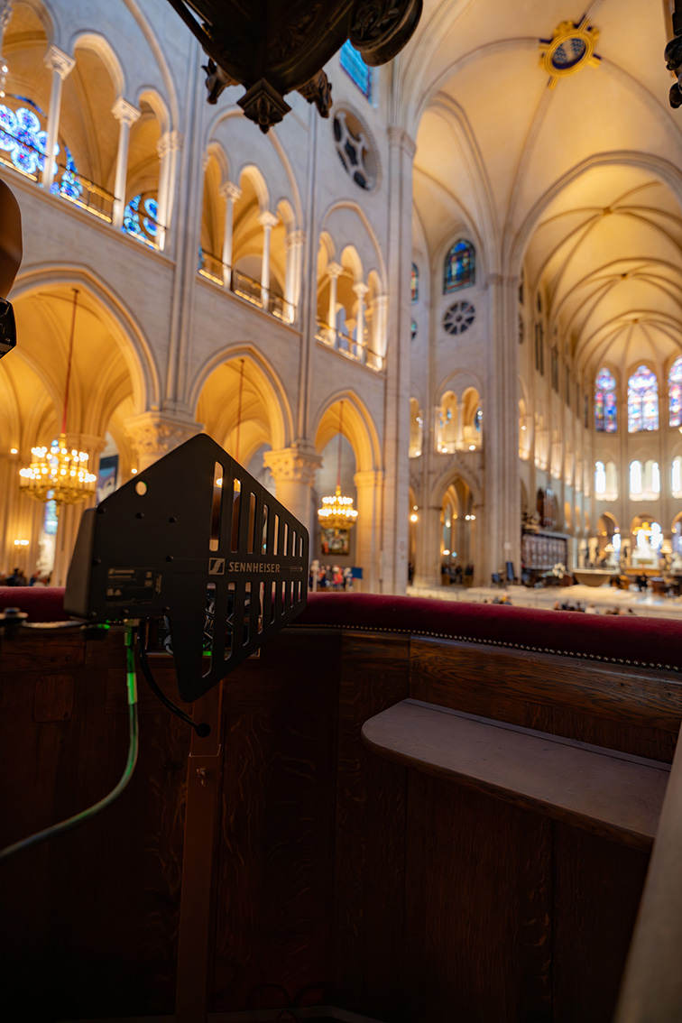 | Unlike traditional RF wireless systems, Spectera does not employ diversity, which halved the antenna requirement for Notre-Dame  (Photo credit: Olivier Allard)

However, in view of the specifications, the team planned to wire the entire Notre-Dame cathedral with fibre rather than RJ45: “When Sennheiser confirmed that a fibre extension works perfectly by simply adding a fibre media converter from the list of models they had tested, we realised that Spectera was the solution we were looking for.”

In a historic site such as Notre-Dame, any technology used must be both durable and virtually invisible, as Alain Richon, project manager for the sound system for the diocese in the cathedral, points out: “Every cable path was carefully considered with the architects, and to anticipate future developments, it seemed logical to opt for fibre. In this context, a system like Spectera, which is based on technologies from the world of telecoms and networks, fits perfectly with this vision.”

Simpler deployment
On paper, the further the study progressed, the more the system seemed perfectly suited to Notre-Dame de Paris, but the stability of Spectera’s RF transmission still had to be verified on site. A full-scale test was therefore organised in early 2024 in a cathedral still under construction: “We were all dressed in white overalls,” recalls Créteur.

Together with Sennheiser’s Hadrien Soulimant (Business Development Manager Professional Audio) and Charly Fourcade (Technical Application Engineer Pro Audio), Créteur set up a test configuration in the middle of the scaffolding. In parallel, a test span was created to check the visual appearance and audio quality of the sound system.

Charly Fourcade, Technical Application Engineer Pro Audio at Sennheiser, during the onsite test organised at the beginning of 2024 in a cathedral that was still a construction site  (Photo credit: Sennheiser) | 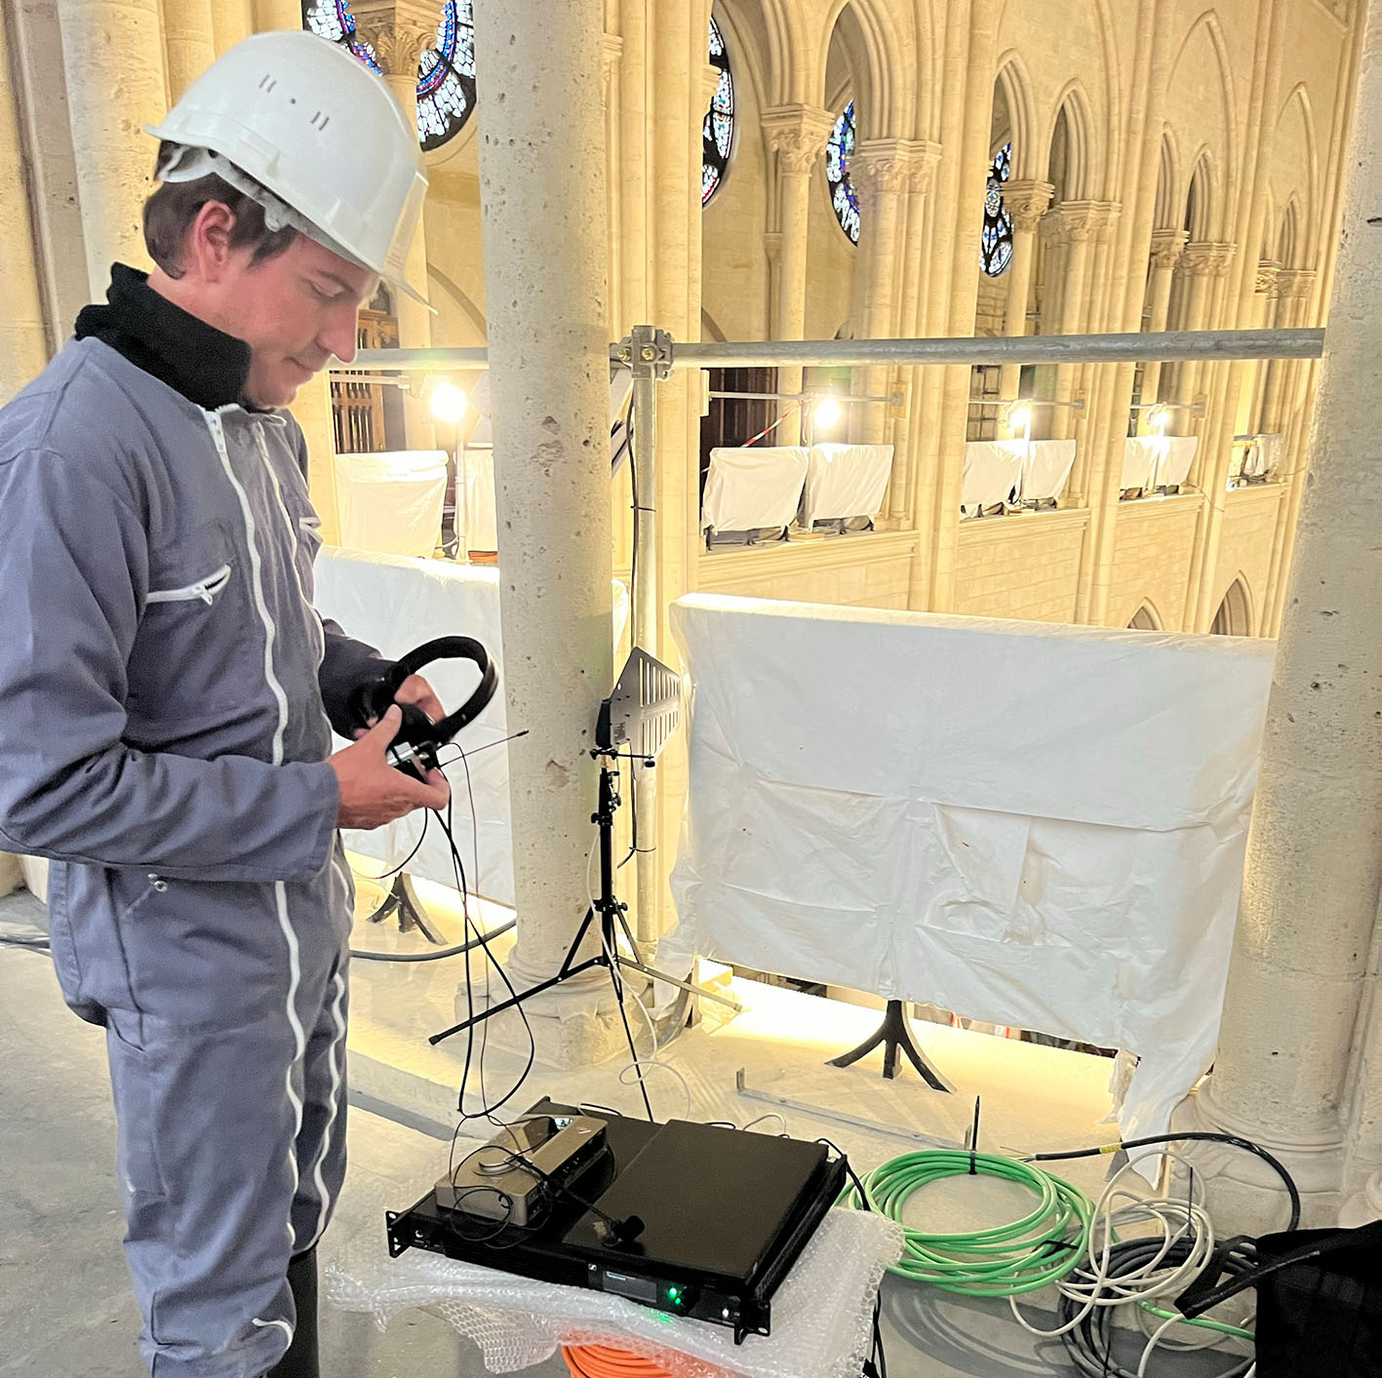

Results were very promising, but still the tight renovation schedule had to be met. Exceptional circumstances called for exceptional measures, and so, in autumn of 2024, Sennheiser delivered a temporary, pre-production configuration comprising a Spectera Base Station and three SEK bidirectional bodypacks. While waiting for the handheld transmitter to become available for Spectera, a Digital 6000 wireless system was also deployed, comprising a two-channel receiver and two handheld microphones.

The Sennheiser mics at the heart of Notre-Dame
Today, liturgical life has resumed at Notre-Dame, with rhythm given by the five daily services. “Every morning before the first mass and every evening after the last mass, worshippers and visitors are welcomed in the narthex for the Angelus prayer,” explains Prades. On the technical side, the choice of microphone varies according to preference, with some priests using a handheld microphone and others a bodypack transmitter with an MKE 40 clip-on microphone, which is appreciated for its discretion and sound quality.

The cathedral also has an audiovisual control room, from which the teams of television channel KTO provide daily broadcasts. “When unobtrusive sound capture is required, the microphone chosen for the altar of Notre-Dame, the MEB 114 boundary microphone, is the most suitable because it is both aesthetic and precise, with very consistent directivity across the entire spectrum. The wireless microphones can also be used for the hosts of concerts by the “Maîtrise Notre-Dame de Paris” choir, which the “Musique Sacrée à Notre-Dame de Paris” association organizes every Tuesday.”

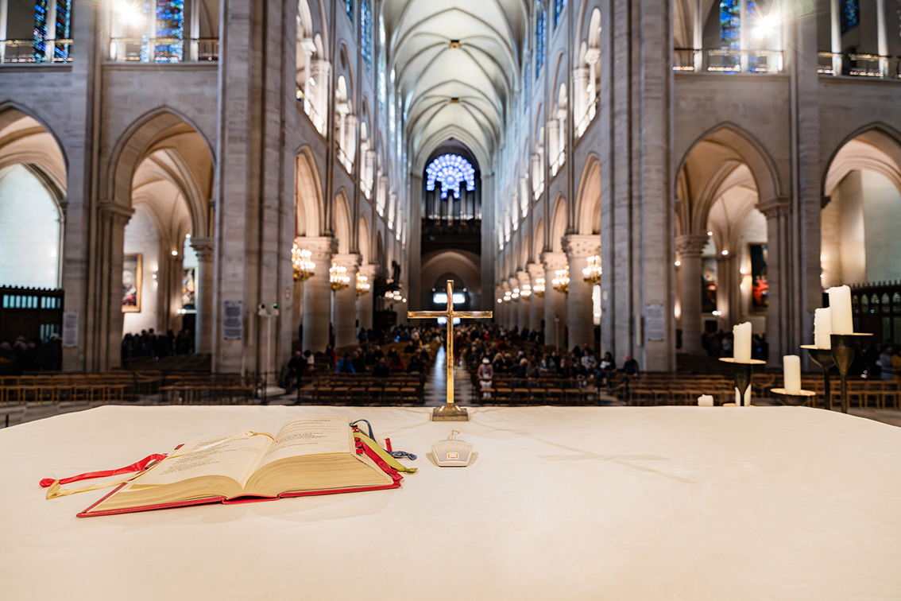 | Highly valued at Notre-Dame for the video recordings of masses: the MEB 114 boundary microphone on the altar is both unobtrusive and aesthetic, with a very consistent pick-up pattern across its spectrum  (Photo credit: Olivier Allard)

Spectera simplifies installation
Notre-Dame’s technical rack is strikingly simple and compact, with the Spectera Base Station occupying a single rack unit while allowing the use of up to 32 microphones and 16 stereo IEMs. With a traditional system, the necessary components would have required much more space and higher electricity consumption. Spectera directly integrates with a DiGiCo console via Dante, using a 4ERA4 matrix, which allows for simple and smooth transport and distribution of audio channels to the console. Initially planned to be located on the gallery at a height of around ten metres, the four antennas were ultimately brought down, providing very stable coverage throughout the cathedral.

Occupying just one unit in the technical rack, the Spectera Base Station (in the middle) may look very compact, but it can handle up to 32 mic channels and 16 stereo IEMs. A classic narrowband system would have demanded much more space and would have had higher current consumption  (Photo credit: Olivier Allard) | 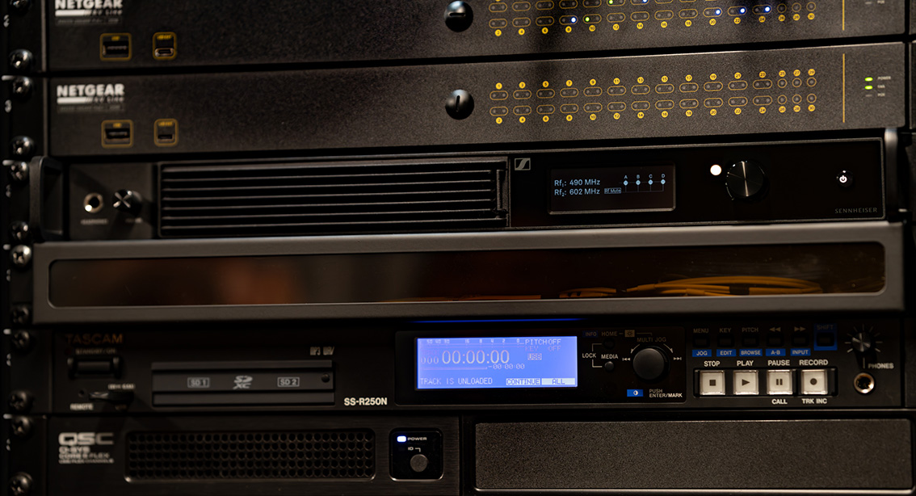

A scalable installation
As soon as the installation had been completed, David Créteur was already planning its future: “There may be occasions when priests need to speak in front of the church. In this case, a fifth antenna would be needed, and we might add that. We already tested such a scenario live, and simply took antenna 4 outside during operation. It worked without having to restart the system.”

Spectera allows Créteur to look at future usage scenarios with confidence: “Spectera gives us the freedom to accommodate a larger number of bodypacks, either permanently or on a rental basis for one-off events in the cathedral. We could also reroute additional channels to the outside to facilitate the work of our regular partners KTO or Radio-France, who often come to Notre-Dame. In addition, thanks to its bidirectionality, Spectera offers new possibilities for sound engineers. When they need to move around to make level adjustments from their tablet, they can now press a PFL (Pre Fader Listening) button and hear it directly through their headphones plugged into an SEK bidirectional bodypack. Even though these uses were not originally requested, we’ve realised that these features can be really useful, and why not take advantage of them since they are already included?”

(Ends)

The high-resolution images accompanying this media release as well as additional photos can be downloaded here. Please make sure to give the photo credits.

About the Sennheiser brand
We live and breathe audio. We are driven by the passion to create audio solutions that make a difference. Building the future of audio and bringing remarkable sound experiences to our customers – this is what the Sennheiser brand has represented for 80 years. While professional audio solutions such as microphones, meeting solutions, streaming technologies and monitoring systems are part of the business of Sennheiser electronic SE & Co. KG, the business with consumer devices such as headphones, soundbars and speech-enhanced hearables is operated by Sonova Holding AG under the license of Sennheiser.

www.sennheiser.com
www.sennheiser-hearing.com

Local Press Contact
Valentine Vialis
valentine.vialis@sennheiser.com
+33 (1) 49 87 03 08

